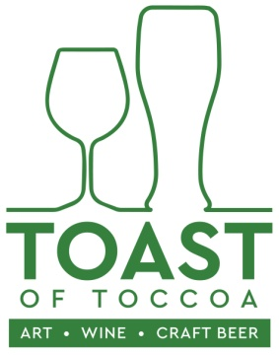
SATURDAY, MAY 4, 2019 / 10 – 5PM
DOWNTOWN TOCCOA

FREE JURIED OPPORTUNITY IN NORTHEAST GEORGIA FOR ARTISTS / APPLY BY APRIL 15TH
Hello Fellow Artist:
Greetings from the Currahee Artists Guild. We are writing to let you know about an exciting opportunity to show and sell your art.
Downtown Toccoa will be hosting its third annual “Toast of Toccoa” featuring: ART – CRAFT BEER & WINE TASTING - UPSCALE FOOD - CLASSIC CAR SHOW – LIVE MUSIC. The Currahee Artist Guild (CAG) is contacting and coordinating artists for this event. The event will be heavily supported with regional advertising and press in advance.
We invite you to apply for booth space for this FINE ART JURIED event. The best news of all is that booth space for artists is FREE of charge.
Here’s how it works:
- There are a total of 35 booth slots available.
- The show is open to: Individual artists, artists wishing to share booth space and Artists’ Guilds who may sell the work of their members.
- All work must be original and handcrafted by the artist. All pieces should be of excellent quality and design. Prints are acceptable if from artist’s original work.
- Each artist or Artists’ Guild must submit the application form (see below) along with 3 photos representative of work that will be sold. (If you were juried into the show last year, you don’t have to submit photos.)
- The deadline to enter is: APRIL 15, 2019
- Notification of acceptance to participate in the juried event will be sent out on: APRIL 20, 2019
Additional information:
- Participants are to provide their own tents and booth set up (access to power is available if needed on a limited basis). All tents should have sufficient weights in case of high winds.
- Art demonstrations are encouraged
- Set up begins at 8:30AM / Take down begins at 5:00PM.
- The event runs from 10am – 5pm. Participants are to have the booth open during those times
- The event will take place outdoors -- RAIN or SHINE
It’s a fun event. We thank you for your consideration and encourage you to apply early.
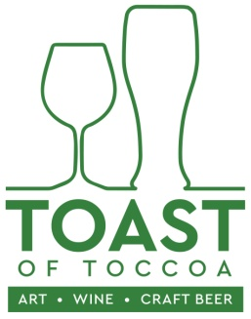
SATURDAY, MAY 4, 2019 / 10 – 5PM
DOWNTOWN TOCCOA

FREE JURIED SHOW & SALE OPPORTUNITY IN NORTHEAST GEORGIA FOR ARTISTS
APPLICATION FORM
Email: gailwatson58@yahoo.com along with 3 photos by APRIL 15, 2019
NAME
(Or Artist Guild Name & Contact Name)
ADDRESS

CITY/ STATE

PHONE

EMAIL
Need Power? ______ YES ________ NO Will you demonstrate art? ______ YES _____NO
Media: (Please check all that apply)
Oil Painting |  | Pottery |  | Fine Craft: (check or list other)
Acrylic Painting |  | Photography |  | - textiles
Drawing |  | Digital Photography |  | - jewelry
Watercolor |  | Pastel |  | - Basket weaving
Mixed Media |  |  |  | - Metal work
 |  |  |  | Other:

______Please check if sharing a booth space with others and list name(s) of booth mate(s).
__________________________________________________________________________________________________________________________________________________________________________

